**EQ-5D**

*Under each heading, please tick the one statement that best describes you* ***TODAY***

**Mobility**

I have no problems in walking about

I have slight problems in walking about

I have moderate problems in walking about

I have severe problems in walking about

I am unable to walk about

**Self Care**

I have no problems washing or dressing myself

I have slight problems washing or dressing myself

I have moderate problems washing or dressing myself

I have severe problems washing or dressing myself

I am unable to wash and dress myself

**Usual Activities**

I have no problem doing my usual activities

I have slight problems doing my usual activities

I have moderate problems doing my usual activities

I have severe problems doing my usual activities

I am unable to do my usual activities

**Pain/Discomfort**

I have no pain or discomfort

I have slight pain or discomfort

I have moderate pain or discomfort

I have severe pain or discomfort

I have extreme pain or discomfort

**Anxiety/Depression**

I am not anxious or depressed

I am slightly anxious or depressed

I am moderately anxious or depressed

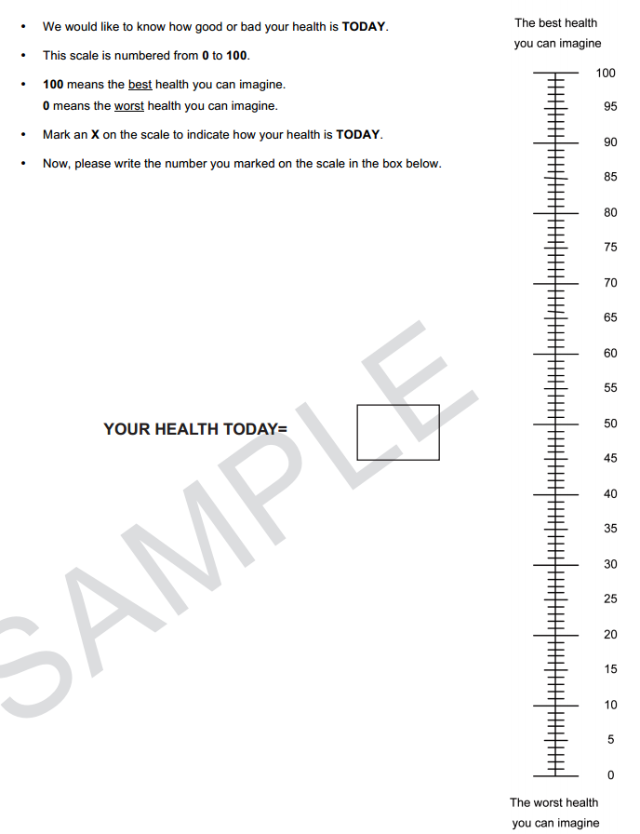 I am severely anxious or depressed

I am extremely anxious or depressed

We would also like to know how good or bad your health is **TODAY**.

* The scale on to the right is numbered 0 to 100
* 100 means the best health you can imagine. 0 means the worst health you can imagine.
* Mark an **X** to indicate how your health is today
* Now, please write the number you marked on the scale in the box below.

**This is the end of the EQ-5D Assessment**